ROCKY POINT FIRE & EMS
25600 Rocky Point Road-Klamath Falls, OR 97601
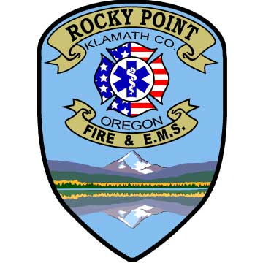

Fire Chief Board Members
David Carpenter Bruce Harp
Interim Chief Pat O Shay
Ph: 541-356-2100 David Carpente
Fax: 541-356-2340 Sharon Nettleton
Chief@rpfire .com Theresa Peterson

Agenda
Monday, September 15th 1:00 p.m.

Minutes

Finances Molatore audit info

Fire Chief job description update

Countywide physician advisor

